PSGS-1610GH
Quick Installation Guide

© 2016, _________ Corporation. All rights reserved. All brand and product names are trademarks or registered trademarks of their respective companies
Contents
Chapter 1 Introduction 1
Overview 1
Front panel of the Switch 1
Rear panel of the Switch 2
Chapter 2 Installing The Switch 3
Package Contents 4
Mounting the Switch in a 19-inch Rack 4
Mounting the Switch on Desk or Shelf 5
Connecting the AC Power Cord 6
Installing SFP Modules 6
Chapter 3 Managing Switch Using the Web Interface 7
Manage the Switch Using Web Browser 7
Chapter 4 Troubleshooting 8
Appendix A Technical Specifications 9
Hardware Specification 9
1000 MBPS Gigabit Ethernet Collision Domain 10

Chapter 1 Introduction

Overview
PSGS-1610GH is a 10 ports PoE GbE Web Smart+ Switch. PSGS-1610GH provide high-performance, IEEE-compliant network solutions. They include powerful management features that you can use to boost performance, and increase productivity.

This guide describes hardware installation and basic troubleshooting for these managed switches.

Front panel of the Switch
Figure 1 Front panel of the switch
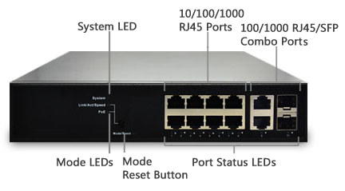

Table 1 Port Status LEDs
LED | Condition | Status
TP (Link/Act/Speed) | Green/Blink | Lit Green when TP link on 1000Mbps  Amber when TP link on 10/100Mbps
TP (PoE) | Green/Off | Lit Green when PoE link good
SFP (Link/Act/Speed) | Green/Blink | Lit Green when SFP link good  Lit Green when SFP link on 1000Mbps.  Amber when SFP link on 100Mbps

Table 2 System Status LED
SYSTEM LED | Condition | status
System | Green  OFF | Lit when power is coming up

Table 3 Mode Status LED
LED | Condition | Status
Link/ACT/Speed | Green  Yellow  OFF | Green when the link on 1000Mbps  Yellow when the link on 100Mbps  Off when the link on 10Mbps
PoE | Green  OFF | Lit Green shows all LED of each port are in PoE Mode

Rear panel of the Switch
Figure 2 Rear panel of the switch
AC Power Socket

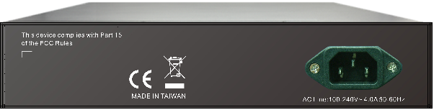

Chapter 2 Installing The Switch

CAUTION: Circuit devices are sensitive to static electricity, which can damage their delicate electronics. Dry weather conditions or walking across a carpeted floor may cause you to acquire a static electrical charge.
To protect your device, always:
- Touch the metal chassis of your computer to ground the static electrical charge before you pick up the circuit device.
- Pick up the device by hold it on the left and right edges only.
- If you use outdoor device connected to switch with cable then you need to install a surge arrester in between outdoor device and switch.
Figure 3 Add a surge arrester between outdoor device and switch
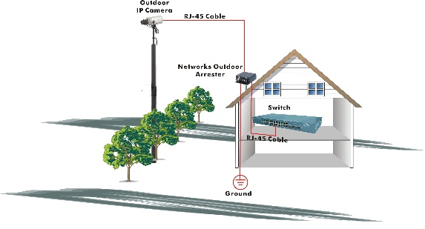

NOTE: The switch is an indoor device; if it is to be used with outdoor devices such as outdoor IP camera or outdoor WiFi AP, then users must install a surge arrester to protect the switch

WARNING:
- Self-demolition on Product is strictly prohibited. Damage caused by self-demolition will be charged for repairing fees.
- Do not place the switch in outdoor environment.
- Before installation, please make sure the input power source meeting the product specification
- Before importing / exporting configuration file, please make sure the firmware version is always the same.

Package Contents
- PSGS-1610GH GbE Management Switch
- Four adhesive rubber feet
- Mounting Accessory (for 19” Rack Shelf, Optional)
- Installation Guide
- AC Power cord

Mounting the Switch in a 19-inch Rack
Step1. Attach the mounting brackets to both sides of the chassis with screws.
Figure 4 Attaching mounting brackets to the switch
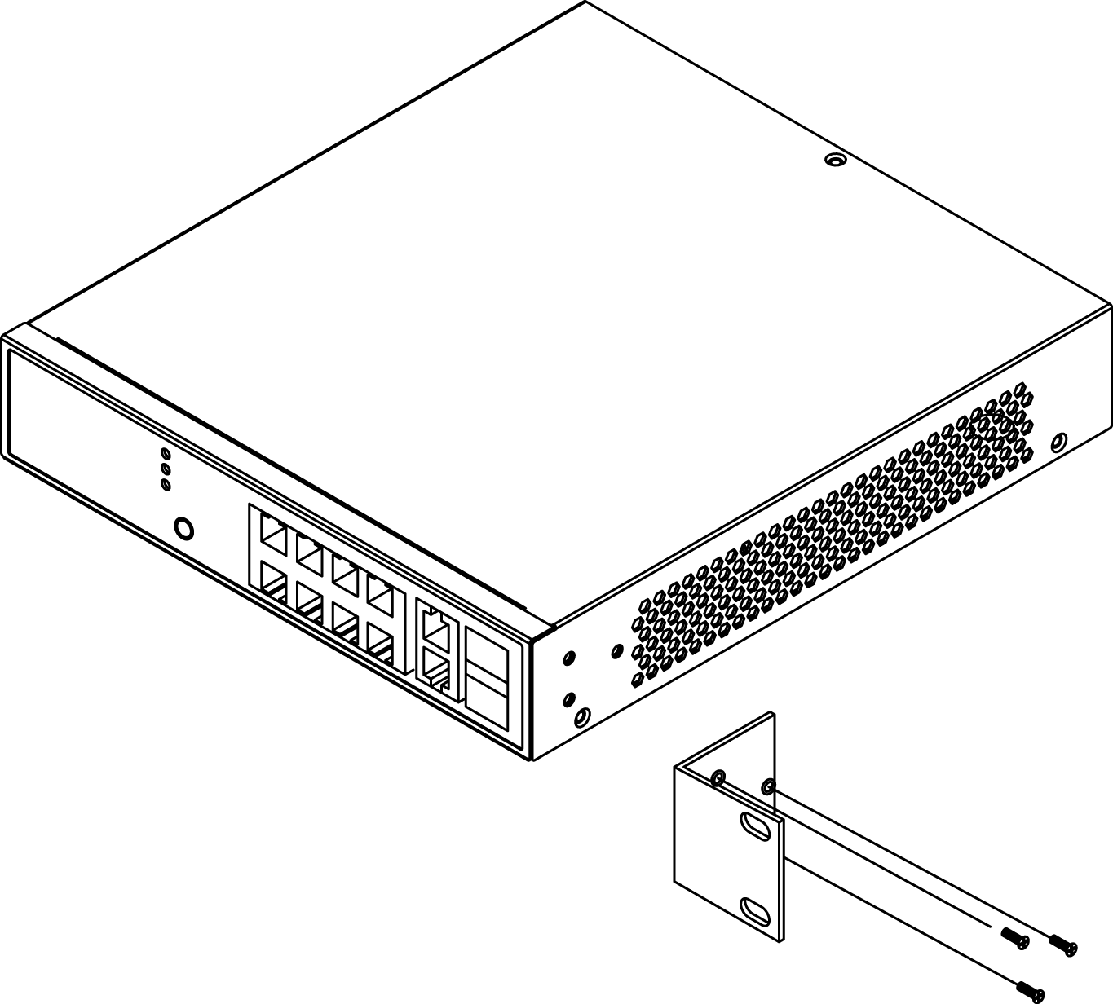
Step2. Place the switch on a rack shelf in the rack. Push the switch in until the oval holes in the brackets align with the mounting holes in the rack posts.
Step3. Attach the mounting brackets to the rack posts with screws.

Figure 5 Attaching mounting brackets to the rack post
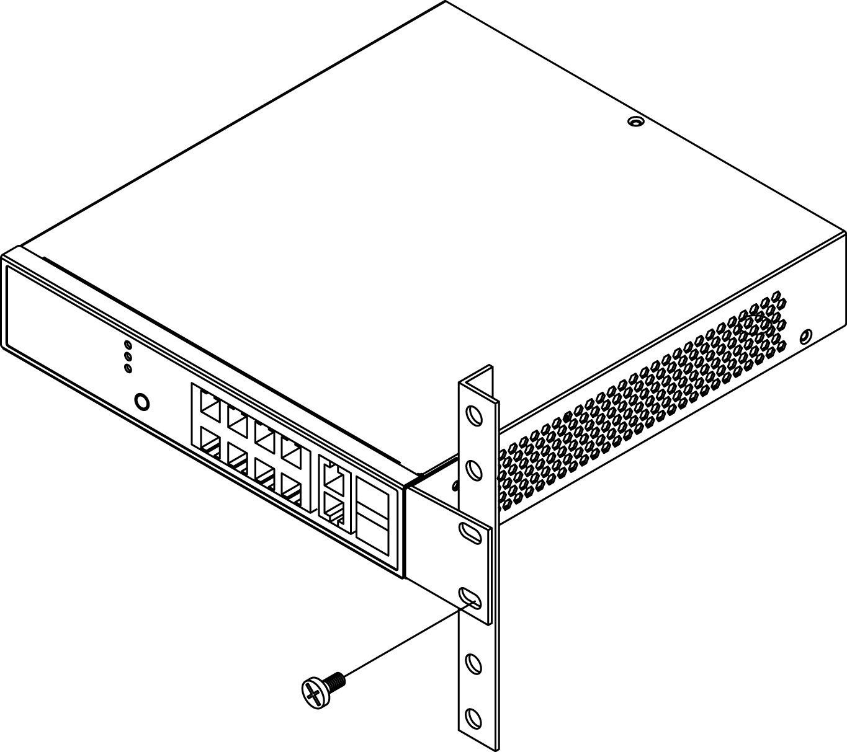

Mounting the Switch on Desk or Shelf
Step1. Verify that the workbench is sturdy and reliably grounded.
Step2. The rubber feet are included in the accessory kit. Attach the four adhesive rubber feet to the bottom of the switch.
Figure 6 Attaching the Rubber Feet
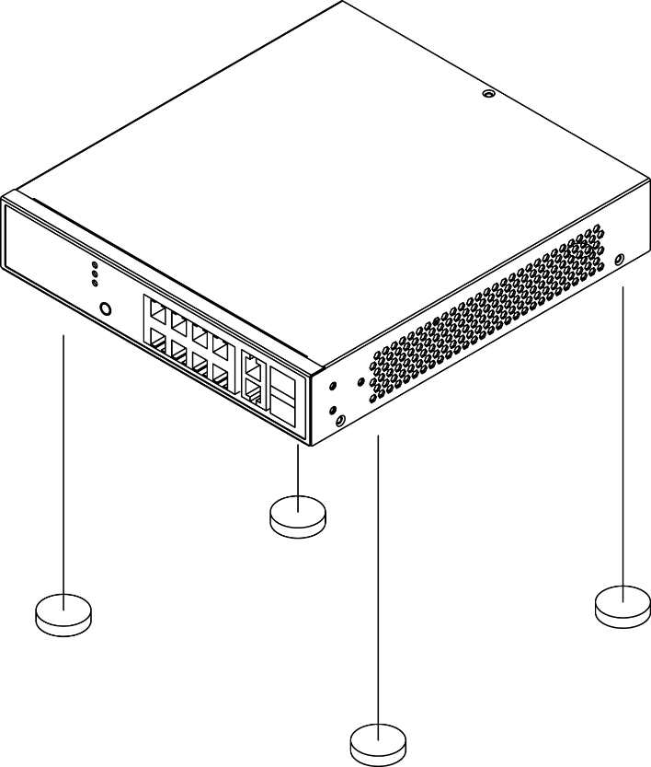

Connecting the AC Power Cord
Figure 7 Connecting the AC power cord to the AC power receptacle
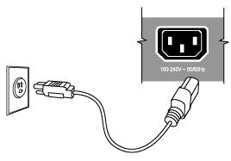
Step1. Connect one end of the AC power cord to the AC power receptacle on the switch.
Step2. Connect the other end of the AC power cord to the AC power outlet.
Step3. Examine the power LED. If it is ON, the power connection is correct.

Installing SFP Modules
You can install or remove a mini-GBIC SFP from a mini-GBIC slot without having to power off the switch. Use only Manufacture mini-GBIC:
Step1. Insert the module into the switch port.
Step2. Press firmly to ensure that the module seats into the connector.
Figure 8 Installing a SFP Module into a SFP Module Slot
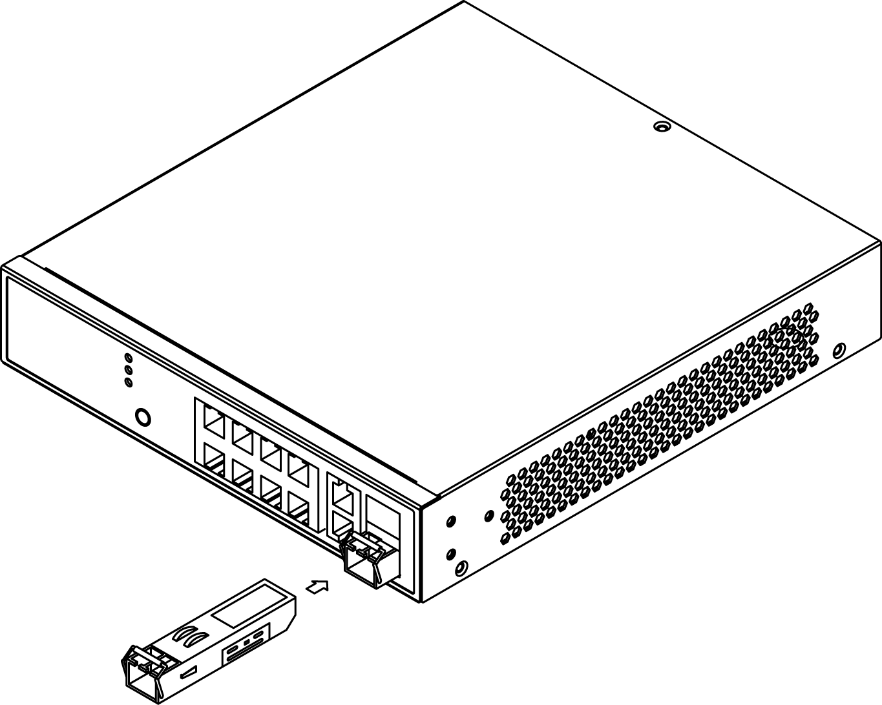

Chapter 3 Managing Switch Using the Web Interface

Manage the Switch Using Web Browser
After you power up the switch for the first time, you can configure the switch using a web browser. For more information about managing the switch, see the user interface manual.
Figure 9 Web Interface login page
Step1. Power on the computer and the switch.
Step2. Plug in the power cable.
Step3. Set the IP configuration on your computer.

NOTE:
- If the switch is using the factory default IP address of 192.168.1.1, you must chose an IP address for the computer in the range of 192.168.1.1—192.168.1.253 that is not already in use.
- If the IP addresses is assigned by a DHCP server, make sure the DHCP server is running and can be reached from the switch and the computer. It might be necessary to disconnect and reconnect the devices for them to discover their new IP addresses from the DHCP server.

Step4. Enter the user name and password (The default username is “admin” and password is empty.), and then click “Login” to login to the switch configuration window.

Chapter 4 Troubleshooting

Troubleshooting Chart
The following table lists Issues, Causes, and Action to possible problems.
Table 4 Troubleshooting Chart
Issues | Cause | Action
SYSTEM LED Off | No power is received. | Check the power cord connections for the switch at the switch and the connected device.  Make sure that all cables used are correct and comply with Ethernet specifications.
Link LED Off | Port connection is not working. | - Check the crimp on the connectors. Make sure that the plug is fully inserted and locked into the port at both the switch and the connecting device.  - Make sure that all cables used are correct and comply with Ethernet specifications.  - Check for a defective adapter card, cable, or port by testing it in an alternate environment where all products are functioning.
Slow file transfer or there is performance degradation. | Half- or full-duplex setting on the switch and the connected device are not the same. | - Make sure that the attached device is set to auto negotiate.  - Check the system message log.
Device is not recognized as part of the network. | One or more devices are not properly connected, or cabling does not meet Ethernet guidelines. | Verify that the cabling is correct. Be sure that all connectors are securely positioned in the required ports. Equipment might have been accidentally disconnected.

Appendix A Technical Specifications

Hardware Specification
Table 5 Hardware Specification
Port Configuration
10M/100M/1G RJ45 Port | 8
100M/1G/2.5G RJ45 Port | --
100M/1G/10G RJ45 Port | --
100M/1G SFP Port | --
1G/2.5G SFP Port | --
1G/10G SFP+ Port | --
GbE RJ45/SFP Combo Port | 2
Console Port | --
Total Ports | 10
PoE Function
IEEE802.3at (PoE+ 30W) | Y
IEEE802.3af (PoE 15.4W) | Y
UPoE(60W) | --
PoE Port | 8
Available PoE Power | 250W
HW Performance
Switching Bandwidth | 20Gbps
Forwarding Performance | 14.9Mpps
MAC Address | 8K
Jumbo Frames | 9216 Bytes
Environemental Specification
Operating Temperature | 0°C to 45°C
Operating Humidity | 10 to 90% RH
Storage Temperature | -20 to 70°C
Storage Humidity | 10 to 90% RH
Mechanical Specification
Dimensions (H) x (W) x (D) mm | 44 x 220 x 242
Weight | 2.1 Kg
FAN Less | Y
Power Source
AC Input | 100V-240V
DC Input | --
AC/DC Dual Input | --

1000 MBPS Gigabit Ethernet Collision Domain
Table 6 Maximum 1000BASE-T Gigabit Ethernet Cable Length
Cable Type | Maximum Cable Length | Connector
Category 5, 5e or 6 100-ohm UTP or STP | 100.m (328 ft) | RJ-45

Table 7 Maximum 1000BASE-SX Gigabit Fiber Cable Length
Fiber Size | Fiber Bandwidth | Maximum Cable Length | Connector
62.5/125 micron multimode fiber | 160 MHz/km  200 MHz/km | 220 m (722 ft)  275 m (902 ft) | LC  LC
50/125 micron multimode fiber | 400 MHz/km  500 MHz/km | 500 m (1641 ft)  550 m (1805 ft) | LC  LC

Table 8 Maximum 1000BASE-LX/LHX/XD/ZX Gigabit Fiber Cable Length
Fiber Size | Fiber Bandwidth | Maximum Cable Length | Connector
9/125 micron single-mode fiber 1310nm | N/A | 10km (6.2 miles) | LC
9/125 micron single-mode fiber 1550nm | N/A | 30km (18.64 miles)  50km (31.06 miles) | LC  LC

Table 9 Maximum 1000BASE-LX Single Fiber Gigabit Fiber Cable Length
Fiber Size | Fiber Bandwidth | Maximum Cable Length | Connector
Single-mode  TX-1310nm  RX-1550nm | N/A | 20km (12.42miles) | BIDI  LC
Single-mode  TX-1550nm  RX-1310nm | N/A | 20km (12.42miles) | BIDI  LC

